  TURTLE GRAPHICS:

        Turtle is an library in python. It enables the users to draw, color and create images easily. The pen that you see in screen is "turtle" and it can be moved in any direction to any extent inorder to create graphics. To install turtle, open command prompt and type "pip install turtle".

To use turtle we have to import it ,so the very first line of the program will be import turtle, If you have installed turtle successfully the first line gets executed, otherwise check with your installation procedures.

FIRST TURTLE PROGRAM:

import turtle

turt=turtle.Turtle()

turt.done()

The color of the turtle(onscreen-pen) can be altered with the help of function named as "colormode()".

It takes integer argument that ranges between 0 to 255.

import turtle

turt=turtle.Turtle()

turt.colormode(255)

turt.done()

CHANGING HEAD-DIRECTION OF THE TURTLE:

The direction of the turtle can be set as required with the help of setheading() function.

It takes angle as parameter. The most common values are setheading(90),setheading(180),setheading(270),setheading(0).

import turtle

turt=turtle.Turtle()

turt.setheading(90)

turtle.done()

[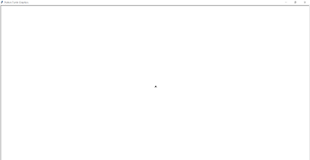](https://www.blogger.com/blog/post/edit/4922005606905068458/6662775403621763945)

TURTLE PROGRAM TO DRAW CIRCLE:

import turtle

turt=turtle.Turtle()

turt.circle(3) #draws circle

turtle.done()

The radius of the circle needs to be specified as an argument for the circle() function.

MY TURTLE PROGRAM:

import turtle

s = turtle.Turtle()

cl=['green','red']

for i in range(100):

    s.color(cl[i%2])

    s.circle(100)

    s.pensize(5)

    s.setheading(i*20)

    s.speed(100) #makes the turtle move faster

turtle.done()

OUTPUT:

[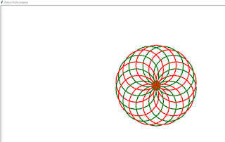](https://www.blogger.com/blog/post/edit/4922005606905068458/6662775403621763945)

PROGRAM:

import turtle

s = turtle.Turtle()

cl=['white','red',]

for i in range(50):

    s.pensize(i)

    s.color(cl[i%2])

    s.setheading(50+i)

    s.forward(100+i*2)

    s.setheading(100+i)

    s.forward(100+i*2)

    s.setheading(-140+i)

    s.forward(100+i*2)

    s.setheading(-78+i)

    s.forward(120+i*2)

    s.speed(10)

turtle.done()

OUTPUT:

[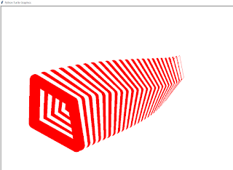](https://www.blogger.com/blog/post/edit/4922005606905068458/6662775403621763945)